**Activity 2: Creating an Ntier Architecture using CF Template contd**

* <https://github.com/asquarezone/awsadministration/commit/998708af37db42298130a5dbf38d10e964da91ab> for the changes done to create a db subnet group.
* Create a stack.  
  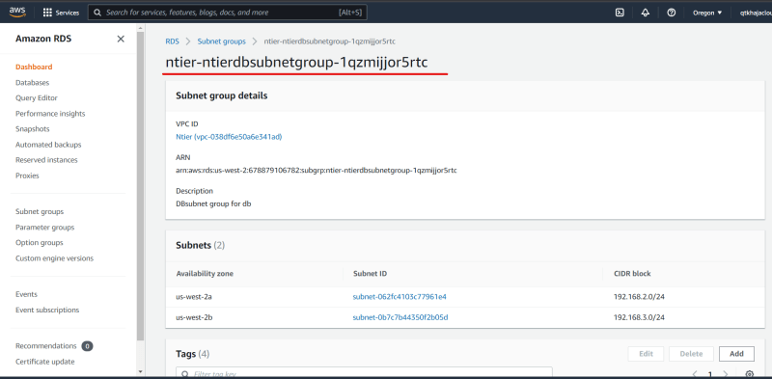
* Lets create a free tier eligible mysql rds db instance <https://docs.aws.amazon.com/AWSCloudFormation/latest/UserGuide/aws-properties-rds-database-instance.html> for the cloudformation db instance definition
* Now after updating the stack we see the database created <https://github.com/asquarezone/awsadministration/commit/111e203493a3999d8aa1a900169a33fad863ae51> for the changes done  
  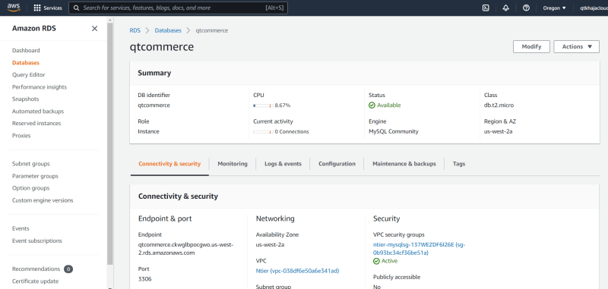
* Now we need to create an ec2 instance <https://docs.aws.amazon.com/AWSCloudFormation/latest/UserGuide/aws-properties-ec2-instance.html> for the resource docs
* Now create the ec2 instance by adding the resource.
* <https://github.com/asquarezone/awsadministration/commit/ad79c7e8975419e02ae025ed1b768b5645b32240> for the changes done and update the stack  
  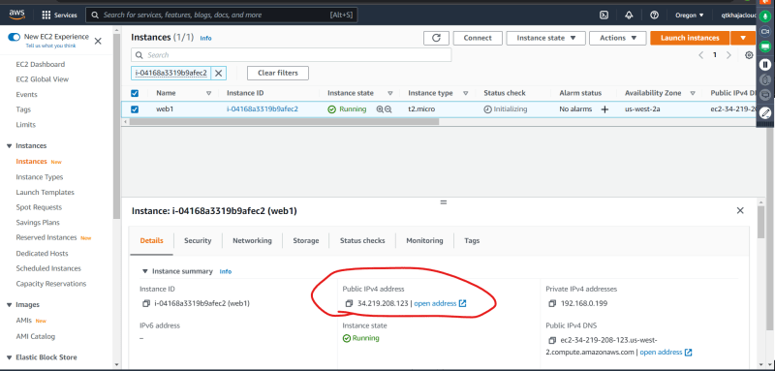

Next Steps:

* Avoid Hardcoding
* Try to make the template reusable across regions
* give options for users to select key pairs
* See the options for parametrizing or making ami id work with all regions
* Add output sections